Ryan G. Cooper

Professor Conlan

CS-405 Module 4 Assignment One

June 2nd, 2024

**Exception Code**

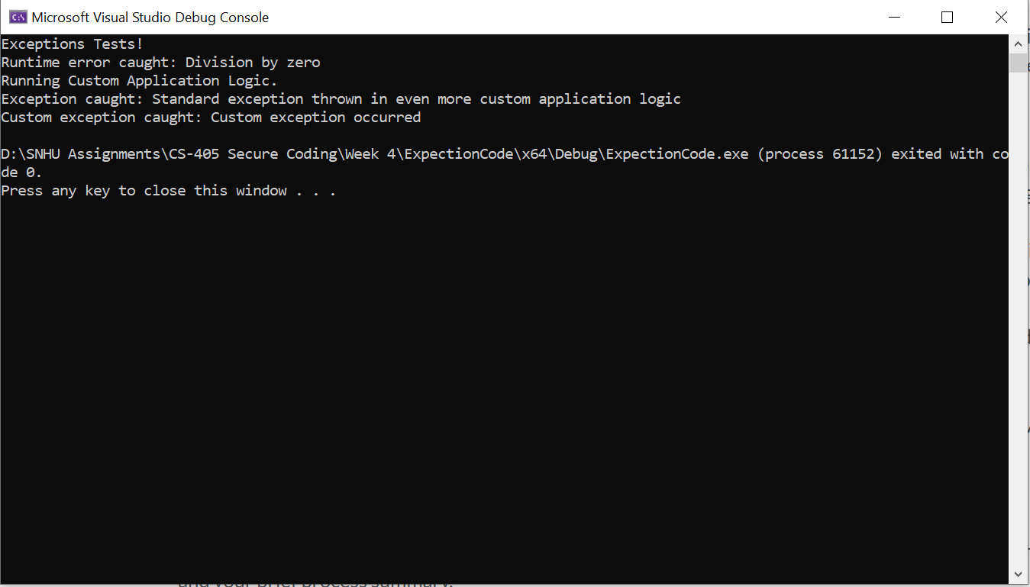

As seen in the above, initially a runtime error due to division by zero was addressed by adding a check in the divide function to throw a std::runtime_error, which was then caught and handled in the do_division function. Standard exceptions were managed by wrapping the do_even_more_custom_application_logic call in a try-catch block within do_custom_application_logic, allowing for the capture and display of exception error messages. A custom exception class CustomException was created, thrown in do_custom_application_logic, and explicitly caught in the main function to handle custom exceptions. Finally, the entire main function was wrapped in a try-catch block to catch CustomException, std::exception, and any other uncaught exceptions, ensuring the application handled all errors and displayed appropriate messages, preventing unexpected crashes.